# HSC Larval Project Methods

**Materials List**

* Larval samples in vials
* Microscope with ToupView camera
* Computer (or HSC laptop) with ToupView software
* Data sheet and/or Excel sheet for recording measurements
* 2 or more petri dishes
* Black/white microscope stage disc
* Calibration slides
* Tweezer set
* Optional: bottle of water with squirt lid (to accurately make water pools for samples)

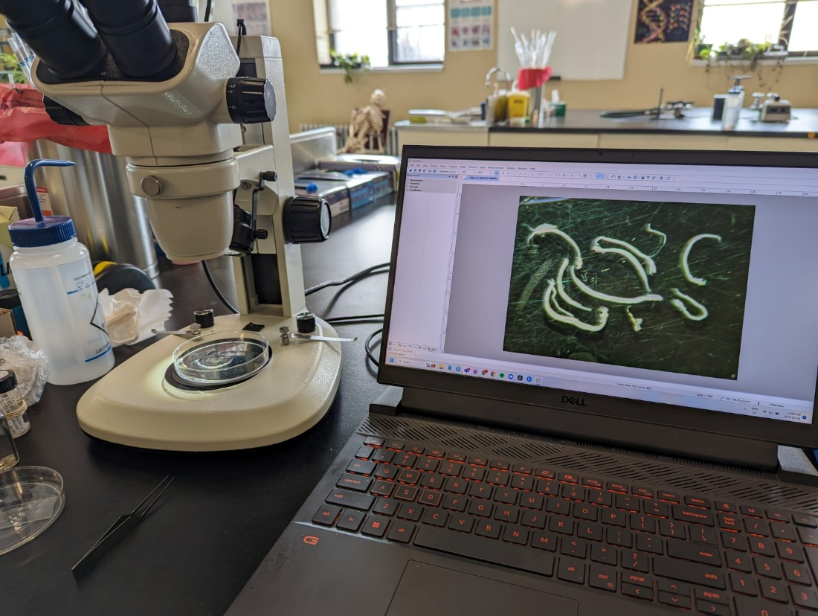

# Setup and Calibration

**Step 1**: Turn on the microscope camera (may always be on and not have a switch) and any stage lights on the microscope. Connect the microscope to the computer via USB. Load ToupView software and double click the listed camera under Camera List on the lefthand side.

**Step 2**: Create a small water pool in the center of one of the petri dishes. Use tweezers to place a few larvae into this pool. Place the microscope disc on the stage with the black side facing up, and place the petri dish on this. Use the microscope knobs to get the preferred depth and clarity of the specimen. You should be able to fit multiple clear specimens in one field of view, and do not need to zoom to a very high magnification of fewer specimens (see example on screen above).

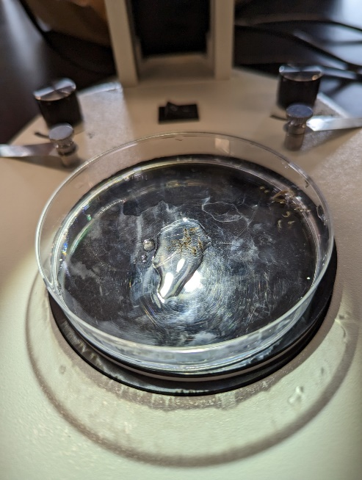

**Step 3:** Remove this petri dish and flip the microscope disc to the white side. Place the calibration slide inside the other petri dish (to mirror the same depth/height as the sample dish). **Do not adjust any of the knobs (clarity/depth) from Step 2**, as it is set to the proper level for the larvae.

**Step 4:** Make sure the upper bar is set to Pixel, NA, 100% for calibration. Calibration will not work otherwise.



**Step 5:** Hit the calibration button which looks like , in the upper tool bar



Or go under Options and hit the calibration button

**Step 6:** This will pull up the calibrate window, in the magnification slot select 10X, for the actual length enter the length of the scale bar that is in the window. (Entire scale bar equals 1 mm), adjust the units as needed.

Note – the actual length cannot be decimals and must be a whole number

**Step 7:** adjust the bars on the screen to the length you put under the actual length, and then hit OK.

**Note**: values will differ but in *general*, depending on the current microscope knob setting, calibration values should roughly be:

0.67: 100,000

1.0 : 125,000

With other magnification levels ranging between these values. You will use depths between 0.67:1 depending on the size of your specimens.

# Clearing Magnification / Calibration

To clear the calibration or to re-do it

**Step 1:** Go to Options and hit Magnifications

**Step 2:** Hit Clear all then hit OK. If you don’t hit OK, it won’t be clear

# Measuring Larvae

**Step 1:** Calibrate the microscope and the program (see steps above).

**Step 2:** Using the dark side of the disk, place a piety dish with a drop of water in the center and a small puddle on one of the sides. The center water drop is to set of the larval for the picture and the side water is to store the larval after measuring.

**Step 3:** Remove a larval and identify it to be herring or a non-herring species. You can line up multiple herring specimens in one field of view. Specimens do not need to be exactly straight (depending on condition), but as straight as possible is preferred. Temporarily dragging the specimens outside of the center water droplet can make it easier to manipulate them, but they should be placed back in water quickly after Step 4.

**Step 4**: Once your field of view has a good amount of properly oriented specimens, use the Capture Image button to freeze the frame.

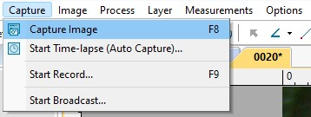

**Step 5a**: Use the Random Connection Curve tool to measure each specimen.

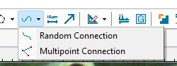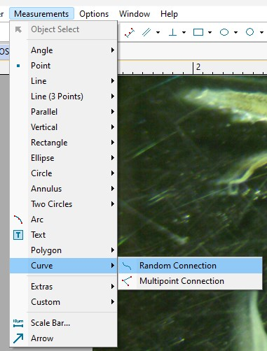

Follow the center line of each specimen and left click to make a new junction in the curve; the tool will continuously update the overall length. Right-clicking will end the current line, after your last point. This tool requires a minimum of 2 connected lines, so on very straight specimens you will still need to make an arbitrary left-click point somewhere along the line for it to record properly. **Any visible/intact yolk sacs should also be measured.**

**Step 5b:** if any measurement lines need to be re-done or deleted, change to the general Selection tool, click the line, and press the [delete] key.

**Step 6**: At this point you should have a field of view of measured herring (including yolk sacs). Non-herring species or debris are fine to be present, but do not need to be measured. Use “Shift+Windows+S” to take a snip of this field of view. In the snipping tool, save the image as the sample ID, and add another -XX if there will be additional screen captures from the same vial (e.g. SB2021-01-01, where SB2021-01 is the vial and -01 is the first set of measurements).

# Data Entry

Recorded measurements should be entered into the Larval Measurements.csv spreadsheet found on the HSC Github repository:

C:\Users\herri\Documents\GitHub\HerringScience.github.io\Source Data\Larval Data\

**Lengthmm** – the specimen length in mm as shown by the Random Connection tool.

**id** – the vial label for the specimen, not including the extra tag if there were multiple screen captures for a single vial (e.g. SB2021-15, not SB2021-15-02); this needs to be exactly as formatted in order to later connect this to the plankton tow data.

**Condition** – Generally only **one** of these conditions are chosen. Possible conditions are: (G)ood, (H)eadless, (T)ailless, or (D)egraded.

Good – *specimen is intact (both head and tail are clear and present), body is not degraded.*

Headless *- incomplete specimen, missing head. Tailless - incomplete specimen, missing tail.* Degraded *- intact specimen, with clear head and tail but poor preservation, degraded overall including lack of pigmentation, eye present, etc.*

**Yolk_sac** – whether the specimen has a yolk sac present (“Y”) or not (“N” or left blank for NA).

**Yolk_sac_length** – the yolk sac length in mm, should always be accompanied by a “Y” under Yolk_sac.

**Preservative** – type of preservative that was used for the original capture of the specimen from the HSC plankton tows, not what preservative the ARC used in their vials of fish larvae. Most likely 4% Formalin.